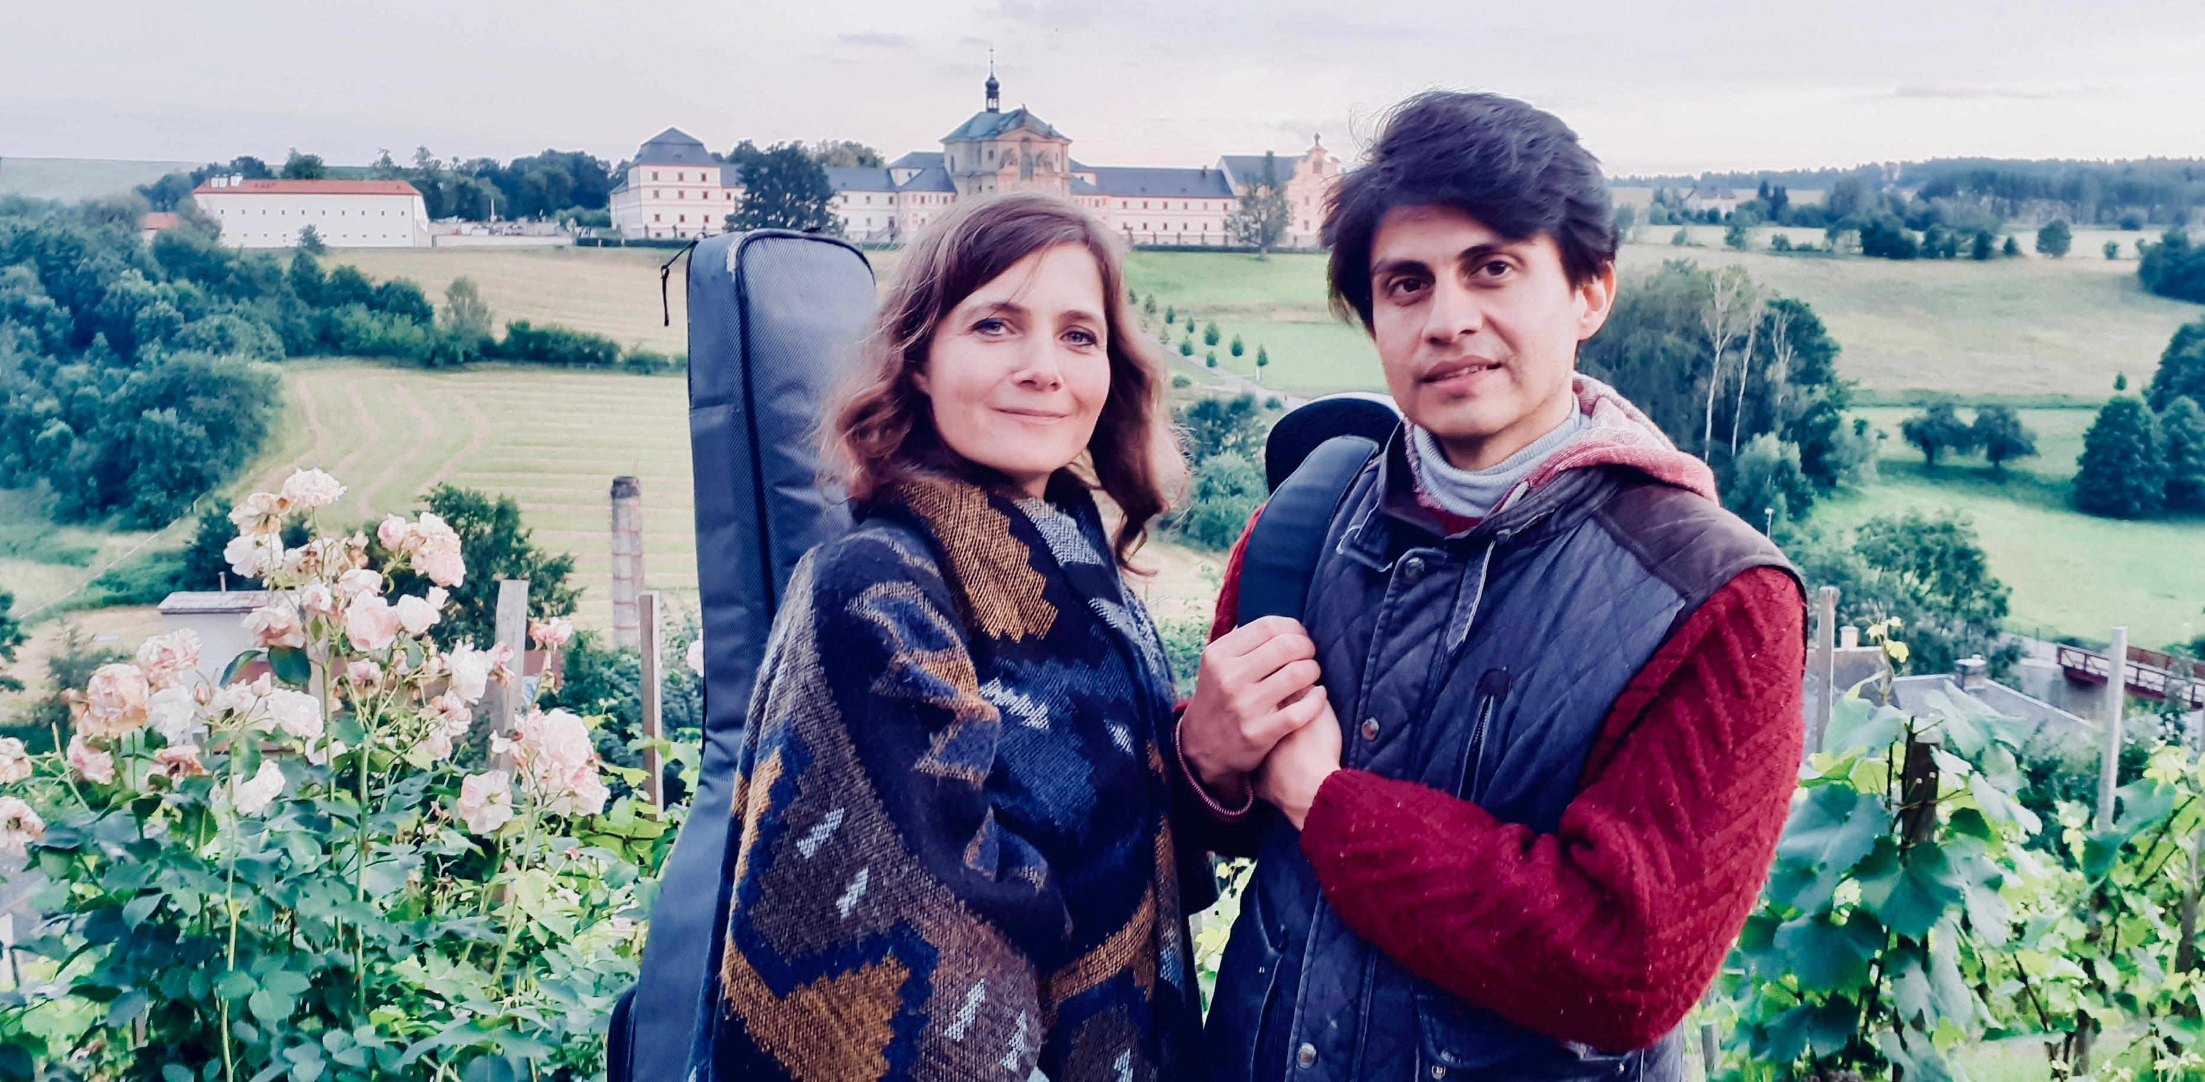

Application for “La dílna” Workshop

Songs and rhythms of Latin America with Gabo Naas (Argentina) and Marta Topferova (CZ)

Dates: August 1-4th, 2024
(with the possibility to arrive on Thursday or Friday - see below)

A) - arrival on Thursday at 11:30h and departure on Sunday at 16:00h
B) - arrival on Friday at 12:30h and departure on Sunday at 16:00h

*Thursday 1.8.2024 extra day - rhythmic and vocal exercises*
11:30-12:00 arrival, accommodation, tour of the premises - meeting in the courtyard of the Kuks Hospital
12:30-13:45 lunch - Na sýpce restaurant
14:00-15:30 opening of the workshop - Latin American rhythms with Gabo - refectory
16:00-17:00 vocal singing, resonance, intonation with Marta - refectory
17:30-19:00 practice of rhythms with singing - refectory

Friday 2.8.2024 traditional program of La Workshop of Latin American songs and rhythms from 14:30
9:45 quiet morning walk and breathing - gardens and valley around the Elbe in Kuks - gardens in Kuks
11:00-11:45 vocal singing, resonance, intonation with Marta - refectory
11:45-12:30 Latin American rhythms with Gabo - refectory
12:30 arrival and accommodation for participants from Friday to Sunday - meeting in the courtyard of the Kuks Hospital
13:00-14:30 lunch - Na sýpce restaurant
14:30-17:30 Latin American songs and rhythms - refectory
18:00-19:30 time for dinner - Baroque or on your own
20:00-21:30 Latin American style accompaniments, time for instrumentalists with Gabe - refectory

Saturday 3.8.2024
9:45 quiet morning walk and breathing - gardens and valley around the Elbe in Kuks - bridge in the village
11:00-13:00 songs and rhythms (possibility to work separately with singers and instrumentalists) - refectory and kitchen in the accommodation area (ground floor)
13:15-14:30 lunch
14:30-17:30 connecting songs and rhythms - refectory
17:30-18:30 strudel/fruit/tea/coffee - refectory lounge
19:30 evening picnic - gazebo, Kuks vineyard

Sunday 4.8.2024
9:45 quiet morning walk and breathing - gardens and valley around the Elbe in Kuks - bridge in the valley
11:00-13:00 repetition of all songs and rhythms - refectory
13:15-14:30 lunch - Na sýpce restaurant
14:30 preparation for the concert - refectory
15:00-16:00 closing concert of La dílna, Marta Topferova & Gabo Naas - refectory
16:00 packing and departure

Your name: .................., email: .................... mobile: ..................

Accommodation at Kuks Hospital? (Double rooms: couples / 2 women / 2 men) YES/NO

A) ARRIVAL on THURSDAY 1.8. - EXTRA DAY - rhythmic and vocal exercises
PARTICIPATION WITH ACCOMMODATION AT KUKS HOSPITAL / CAPACITY 29 beds: course fee 5800 CZK or 230 EUR, including accommodation at Kuks Hospital (3 nights Thursday, Friday and Saturday)
PARTICIPATION WITH OWN ACCOMMODATION OUTSIDE KUKS HOSPITAL: Course fee without accommodation 4200 CZK or 167 EUR
B) ARRIVAL on FRIDAY 2.8. - TRADITIONAL PROGRAM of workshops of Latin American songs and rhythms
PARTICIPATION WITH ACCOMMODATION AT KUKS HOSPITAL / CAPACITY 29 beds: Course fee 4500 CZK or 178 EUR, including accommodation at Kuks Hospital (2 nights Friday and Saturday)
PARTICIPATION WITH OWN ACCOMMODATION OUTSIDE KUKS HOSPITAL: Course fee without accommodation 3400 CZK or 135 EUR
- meals (several restaurants in Kuks and within 1 km, small community kitchen available in the accommodation part of Kuks Hospital)

To confirm your spot in the workshop, please send the course fee to the account below as soon as possible, the workshop with accommodation at Kuks Hospital is limited to 29 participants.

Please also send your registration form to info@martatopferova.com

Payment terms and cancellation policy below.

BANK ACCOUNT - Komerční banka: 123-606010297/0100
SWIFT or BIC code: KOMBCZPPXXX

Please add to the bank transfer: course fee Workshop Kuks 2024

What is your musical experience? ..................

What would you most like to work on? ..................

If you would like to sign up at the last minute (a day or less in advance), it is best to call +49 170 679 8314.

Thank you and I look forward to seeing you!
Marta Topferova

WEB: www.martatopferova.com
EMAIL: info@martatopferova.com

PAYMENT TERMS
By paying the course fee, the participant also agrees to the terms and conditions of the courses and confirms that he/she is aware of the content of these terms and conditions, cancellation policy and course conditions and agrees to them in full. The payment of the course fee is considered to be an expression of free will of each applicant and he/she hereby confirms that he/she has not done so under duress or coercion. Should a situation arise where a participant has paid the fee late and cannot be enrolled due to the workshop being full, the full amount of the fee will be refunded to the participant. Should the participant decide to leave the workshop before the end of the workshop, the participant will not be entitled to a refund of any part of the fee. Should the workshop be cancelled by the organizer, the course fee will be refunded in full to the participant.

CANCELLATION POLICY
All requests for cancellation of paid course fees can only be sent in writing by email to info@martatopferova.com and the date of receipt by email is considered to be decisive. As email can sometimes be unreliable, please check within two days of sending the email that it has been received by calling +49 170 679 8314, preferably by text message. Cancellations will not be accepted by any other means (phone, text or otherwise). It is always the case that if the participant finds a replacement for him/herself at the time of cancellation, he or she doesn’t have to pay a cancellation fee!
- For cancellations more than 1 month before the start of the workshop, the cancellation fee is 25% of the course fee.
- For cancellations between 1 month and 14 days before the start of the workshop, the cancellation fee is 50% of the course fee.
- In case of cancellation less than 14 days before the start of the workshop, the cancellation fee is 100% of the course fee. In case of sudden illness documented by a medical report, the participant who could not be present at the paid workshop will have the opportunity to attend the next workshop as a substitute if there are vacancies at the time of registration.

